DATA STRUCTURE MINI PROJECT

GROUP 7 – CAR POOLING APPLICATION
Aim :
To develop a secure, user-friendly platform that connects commuters traveling on similar routes to share rides. By optimizing vehicle occupancy, the application intends to significantly reduce individual travel costs, alleviate urban traffic congestion, and lower the overall carbon footprint of daily commuting.

Objectives :
The objective of the Car Pooling Management System is to develop a user-friendly and efficient platform that facilitates ride-sharing among commuters by connecting drivers with empty vehicle seats to passengers traveling in the same direction. This system aims to reduce traffic congestion, lower transportation costs, and minimize environmental pollution by promoting shared travel. It seeks to improve commuter coordination through advanced search filters, real-time ride matching, and secure communication. Additionally, the platform enhances user safety and trust with features like profile verification and ride history. Overall, the system encourages sustainable, economical, and eco-friendly transportation practices in urban and semi-urban areas.

Scope :
The project's scope is defined by its ability to automate the ride-sharing process through the following modules:
- User Management: Secure on boarding via registration and login for both drivers and passengers, including profile management.
- Ride Posting: Tools for drivers to offer rides by specifying details such as source, destination, timing, available seats, and estimated fares.
- Search and Matching: Advanced search filters and real-time ride matching to help passengers find the most relevant trips.
- Booking: A system for passengers to book seats directly
- Integrated Payments: A module for managing fare calculations and processing online or offline payments.
- Community and Safety: Features such as user reviews, feedback systems, and ride history to build trust and maintain service quality

Source Code Snippet:-
Booked_trip.php
// get customer email from admin_login
$result = mysqli_query($conn,"INSERT INTO user_post_trip( email, name, address, date, free_seat, mobile, category)
VALUES('$get_email','$get_name', '$get_address', '$get_date', '$get_seat',
'$get_mobile', '$get_category')");

// check for empty result
if($result)
{
// success
$response["success"] = 1;

// echoing JSON response
echo json_encode($response);
}
else
{
// unsuccess
$response["success"] = 0;

// echoing JSON response
echo json_encode($response);
}
?>

credit_pay_get.php
// check for post data
$data = json_decode(file_get_contents("php://input"));
$get_email = ($data->email);

$result = mysqli_query($conn,"SELECT * FROM user_post_trip where receive_email='$get_email'");
if(mysqli_num_rows($result))
{
$response["details"] = array();
while($Alldetails = mysqli_fetch_array($result))
{
// temp user array
$details = array();
$details = $Alldetails;

array_push($response["details"],$details);
}
$response["success"] = 1;
echo json_encode($response);
}
else
{
$response["success"] = 0;
echo json_encode($response);
}
?>

cust_trip_get.php
// check for post data
$data = json_decode(file_get_contents("php://input"));
$get_email = ($data->email);

$result = mysqli_query($conn,"SELECT * FROM user_post_trip where email='$get_email'");
if(mysqli_num_rows($result))
{
$response["details"] = array();
while($Alldetails = mysqli_fetch_array($result))
{
// temp user array
$details = array();
$details = $Alldetails;

array_push($response["details"],$details);
}
$response["success"] = 1;
echo json_encode($response);
}
else
{
$response["success"] = 0;
echo json_encode($response);
}
?>

feed_get.php

$result = mysqli_query($conn,"SELECT * FROM feed_back where email='$get_email'");

if(mysqli_num_rows($result))
{
$response["details"] = array();
while($Alldetails = mysqli_fetch_array($result))
{
// temp user array
$details = array();
$details = $Alldetails;
array_push($response["details"],$details);
}
$response["success"] = 1;
echo json_encode($response);
}
else
{
$response["success"] = 0;
echo json_encode($response);
}
?>

SCREENSHORT :
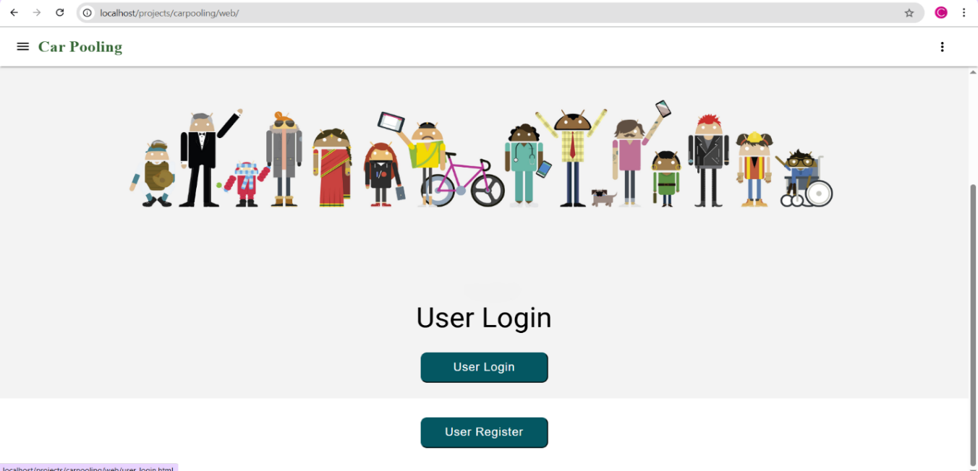
This screen represents the landing page of the Car Pooling application. It features a clean, minimalist UI with a white header and a prominent, colourful banner illustrating a diverse group of people. The page clearly provides two primary call-to-action options: a "User Login" button and a "User Register" button, allowing users to either access their accounts or sign up for the service. The layout uses ample white space and a simple vertical alignment to ensure a user-friendly experience.

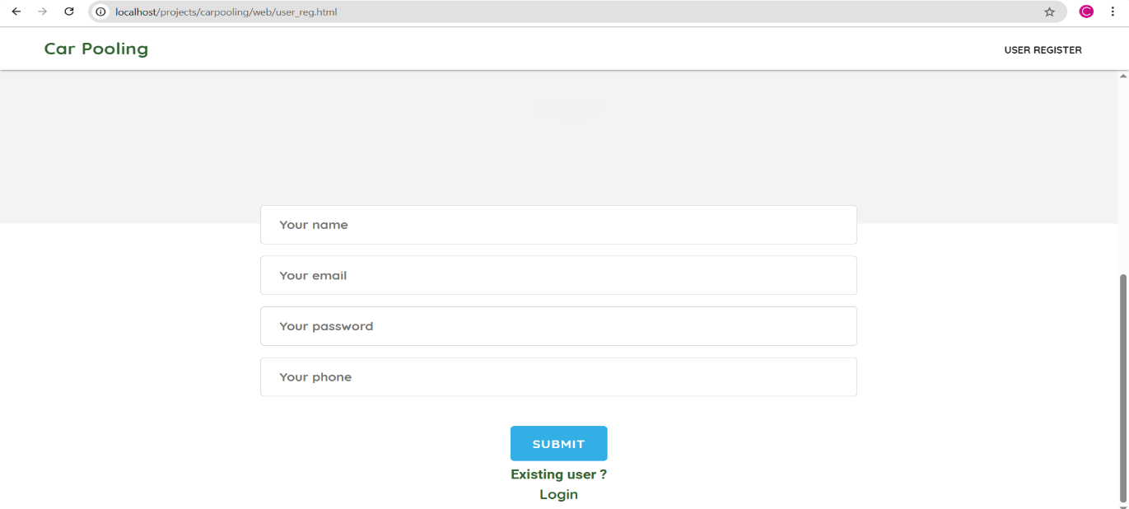
This screen represents the registration page of the Car Pooling application. It features a clean, straightforward registration form designed for new users to create an account. The form includes input fields for "Your name," "Your email," "Your password," and "Your phone," followed by a prominent blue "SUBMIT" button. Below the form, an "Existing user? Login" link is provided to help navigate current users back to the login page.

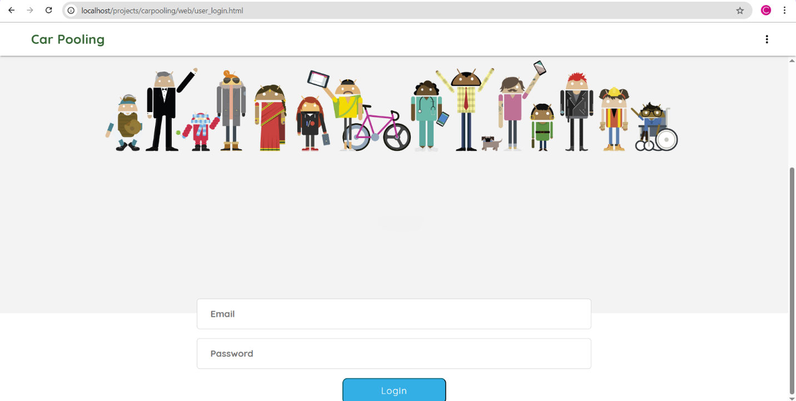
This screen represents the login page of the Car Pooling application. It maintains a consistent visual identity with the landing page, featuring the same diverse banner of Android-style characters and a clean white header. The center of the page focuses on a simple authentication form with two clear input fields for "Email" and "Password".

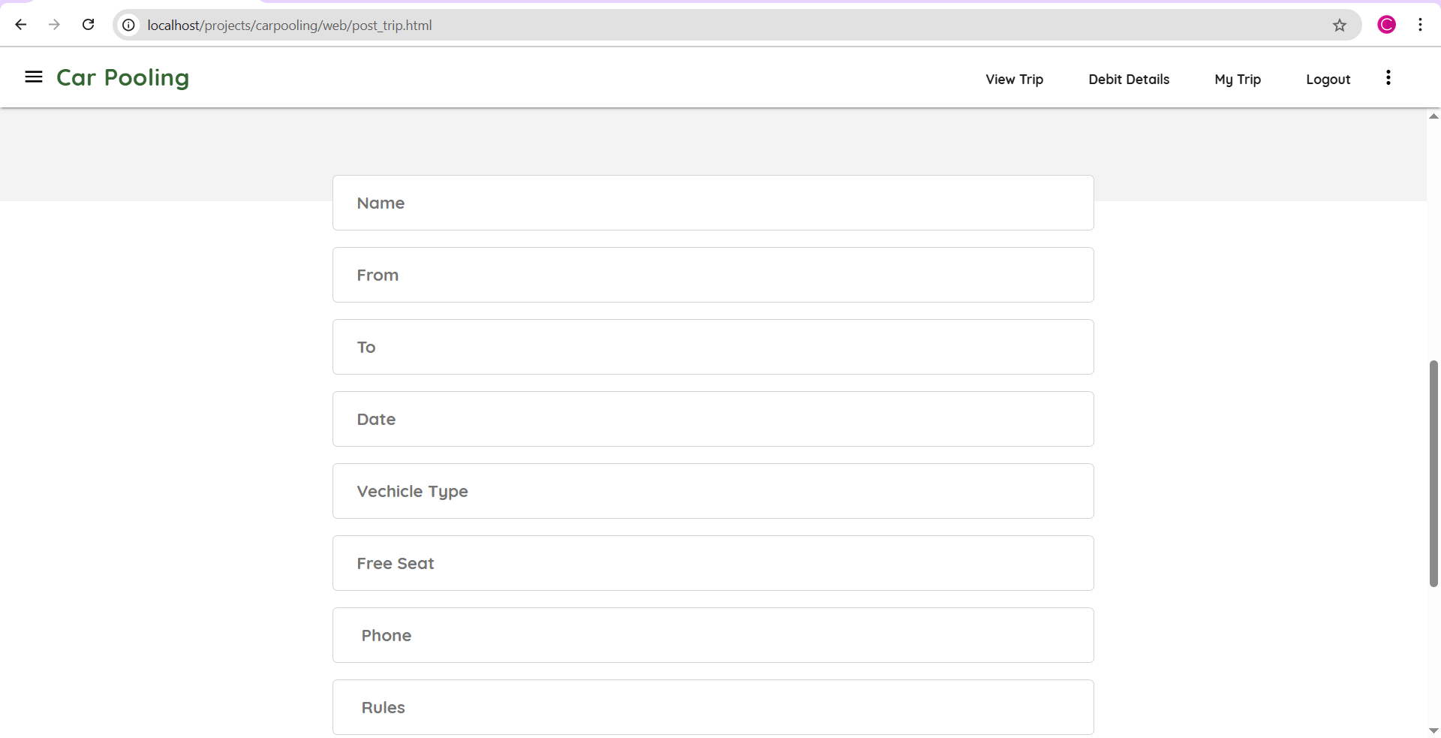
This screen represents the Post Trip page of the Car Pooling application, where users can offer a ride to others. The interface transitions to a functional dashboard layout, featuring an expanded navigation bar with options like "View Trip," "Debit Details," "My Trip," and "Logout". The core of the page consists of a comprehensive input form designed to capture essential journey details, including "Name," "From," "To," "Date," "Vehicle Type," "Free Seat," "Phone," and "Rules". This structured format ensures that all necessary information is collected to facilitate a safe and organized carpooling experience.
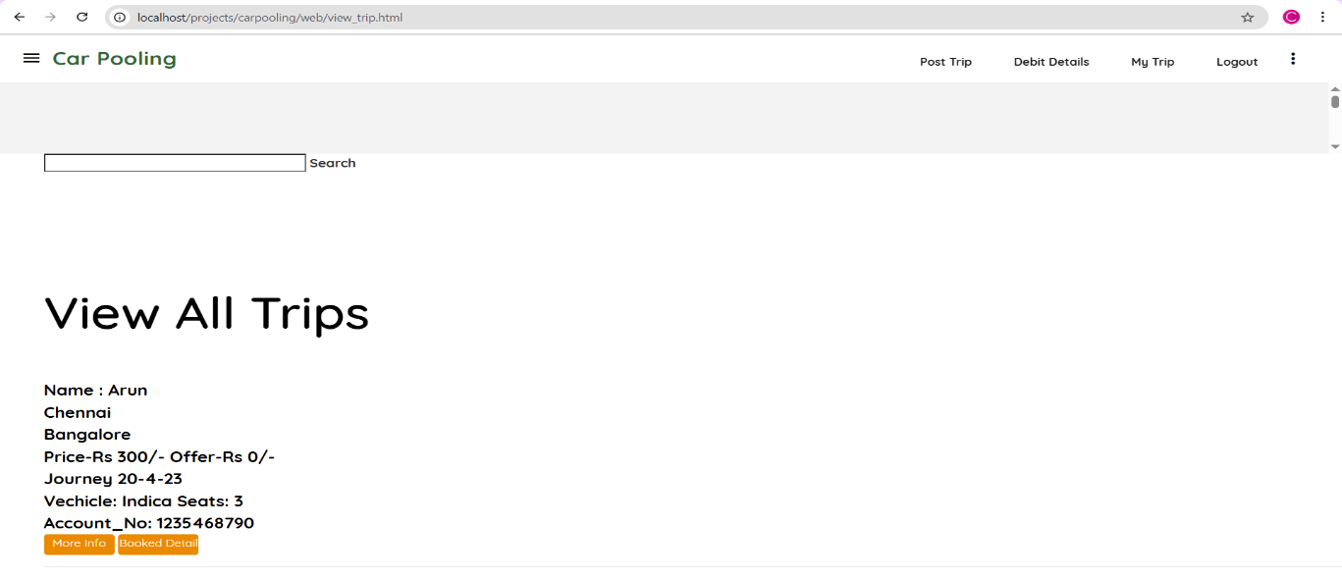
This screen represents the View All Trips page of the Car Pooling application, acting as the search and discovery hub for users looking for a ride. The interface features a functional search bar at the top, allowing users to filter through available journeys. Below the search area, a list of available trips is displayed with detailed information including the driver's name, origin, destination, price, journey date, vehicle type, available seats, and an account number for transactions. Each trip entry is accompanied by "More Info" and "Booked Detail" action buttons, providing a clear path for users to finalize their travel arrangements. The top navigation bar remains consistent, offering quick links to "Post Trip," "Debit Details," "My Trip," and "Logout".

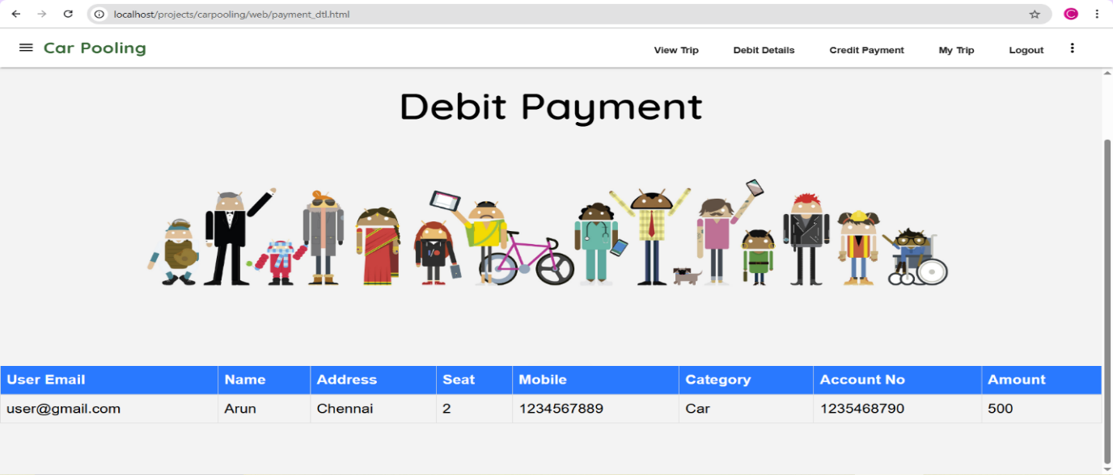
This screen represents the Debit Payment page of the Car Pooling application, providing users with a summary of their transaction history or pending payments. The interface features the familiar colorful banner of diverse characters, maintaining visual consistency across the platform. Below the banner, a structured data table displays detailed transaction records, including the User Email, Name, Address, Seat count, Mobile number, Category, Account Number, and the total Amount. The top navigation bar is fully expanded to include links for "View Trip," "Debit Details," "Credit Payment," "My Trip," and "Logout," ensuring easy access to all financial and trip management features.
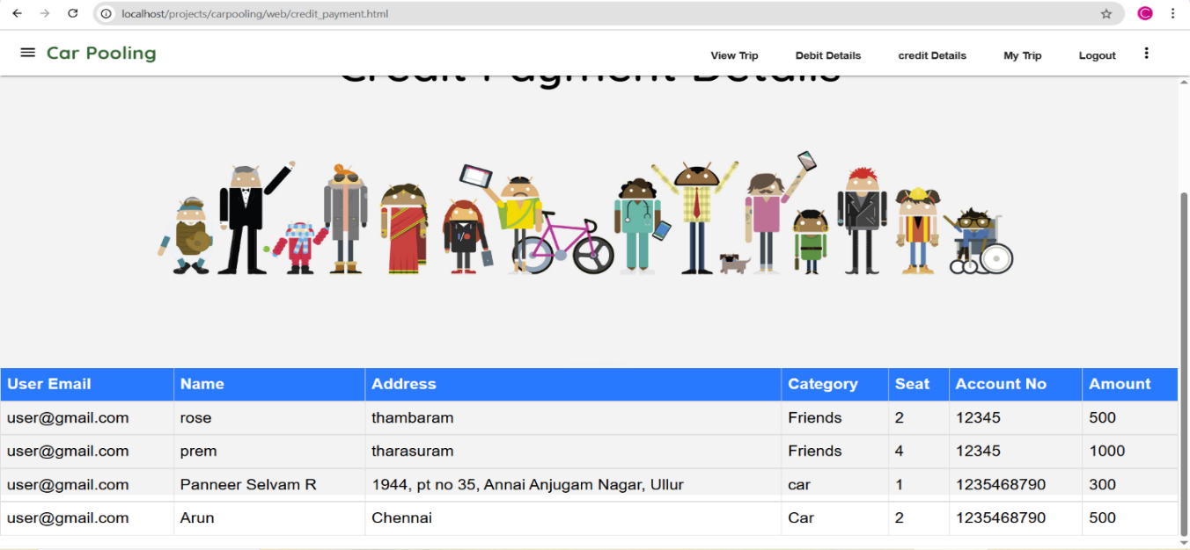This screen represents the Credit Payment Details page of the Car Pooling application. It serves as a financial ledger or summary dashboard for incoming payments. The interface continues to use the application's signature banner of diverse characters to maintain visual branding consistency. Below this, a detailed data table displays multiple payment records, including the User Email, Name, Address, Category, Seat count, Account Number, and the total Amount. The navigation bar at the top provides seamless access to other core modules like "View Trip," "Debit Details," "credit Details," "My Trip," and "Logout".

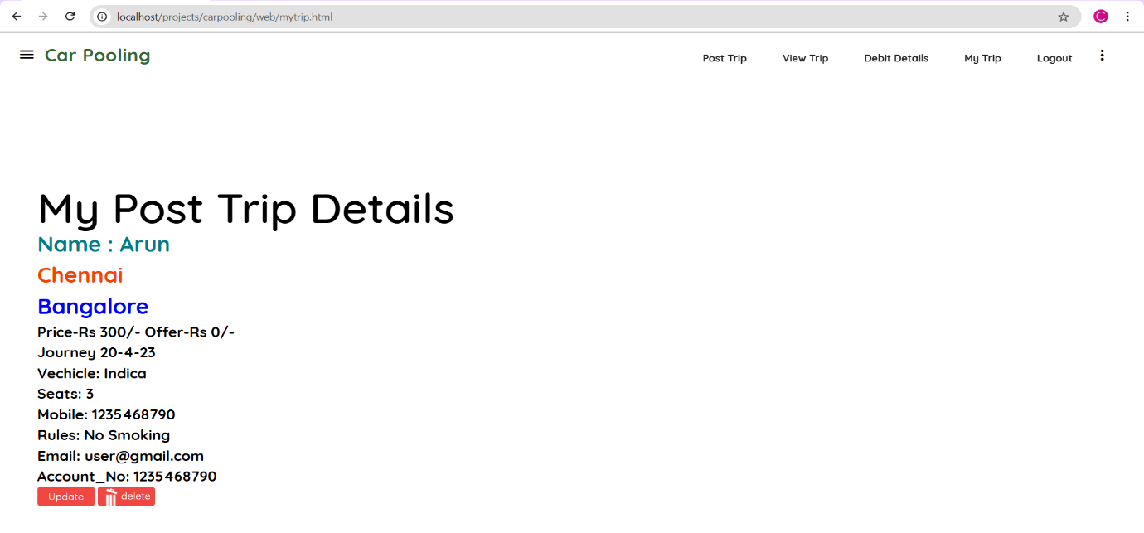
This screen represents the My Post Trip Details page of the Car Pooling application, which allows users to manage the rides they have specifically created. The interface displays a comprehensive summary of a single trip, including the driver's Name, Route (From/To), Price, Journey Date, Vehicle Type, available Seats, Mobile number, Rules (e.g., "No Smoking"), Email, and Account Number. To provide full control over the trip listing, the page includes functional "Update" and "Delete" buttons at the bottom. The top navigation bar remains consistent with the rest of the application, allowing for quick navigation between "Post Trip," "View Trip," "Debit Details," "My Trip," and "Logout".
Brief Overview of the Project:
The Car Pooling Management System is a web platform designed to help commuters share rides. It connects drivers who have empty seats with passengers traveling on the same route.The project aims to make daily travel more affordable and eco-friendly. By sharing rides, users can split fuel costs, reduce traffic congestion, and lower vehicle emissions.
Key Features:
- Ride Posting: Drivers can list their destination, timing, and available seats.
- Easy Booking: Passengers can search for routes and book seats instantly.
- Security: Includes user registration, secure login, and a feedback system to ensure a safe community.
- Modern Tech: Built using PHP for the backend, MySQL for data, and AngularJS for a smooth user experience.
Problem Statement :
- Lack of Real-Time Matching:
Most traditional or semi-automated systems do not provide dynamic, real-time ride matching based on location or time, making it hard to find instant ride partners.
- Poor User Verification:
There's usually no proper identity verification, leading to trust and safety concerns among users, especially when sharing rides with strangers.
- Limited Reach & Scalability:
Many ride-sharing apps work in limited geographic regions or among limited groups, lacking the scalability to handle large user bases effectively.
- Coordination Issues:
Without a centralized system, it becomes difficult to coordinate trip details like pick-up points, drop locations, and timings smoothly.
- No Trip Optimization:
Current systems do not factor in traffic conditions, weather updates, or route deviations, leading to inefficient travel and delays.
- Low Feedback Mechanism:
Feedback or rating systems are either missing or poorly implemented, making it hard to identify trustworthy users.

Solution Approach :
The proposed Car Pooling Management System is a web and mobile-based application designed to streamline and automate the process of ride-sharing between individuals traveling along similar routes. The system allows registered users to either offer a ride or book a ride based on their travel needs. It incorporates real-time ride matching, route optimization, automated payment, and security features such as user reviews.
The system enables users to post detailed trip information like source, destination, available seats, departure time, and fare. Interested passengers can search for suitable rides using advanced filters (location, time, cost, etc.) and book them directly. The application also supports features like ride tracking, payment history, feedback mechanism, and ride history for future references. Admins can monitor trip data and feedback to ensure a secure and fair platform.
This system is intended to promote eco-friendly commuting, reduce traffic congestion, and improve transportation affordability.
Key Outcomes / Results :
- Real-Time Ride Matching:
Matches passengers with drivers instantly based on current location, destination, and time, improving efficiency and convenience.
- User-Friendly Interface:
A simple and intuitive UI makes it easy for users to post and find rides quickly, encouraging widespread adoption.
- Cost-Effective Travel:
Reduces fuel and vehicle maintenance costs by splitting travel expenses among multiple passengers.
- Traffic and Pollution Reduction:
Fewer vehicles on the road lead to less traffic congestion and lower emissions, benefiting the environment.
- Integrated Payment System:
Supports online and in-app payments with automatic fare calculation and transparent transaction records.
- Trip Management Features:
Users can view upcoming trips, manage bookings, track trip status, and view payment or feedback history in one place.
- Feedback and Rating System:
Encourages accountability and improves service quality through user reviews and ratings.
- Scalable and Flexible:
Can be scaled to support organizations, universities, or even cities with custom modules as needed.
- Encourages Community Sharing:
Builds a sense of community and cooperation by connecting people with similar travel routes.

Work Bifurcation / Individual Member Contribution:
The project was developed through effective teamwork, where responsibilities were divided among members based on individual skills to ensure smooth execution and timely completion.
Roll No. | Name | Contribution
70 | Areeb Khan | Requirement analysis, problem identification, and preparation of project flow and module design .
72 | Shaziya Khan | Design and implementation of User Login and validation logic
73 | Shezaan Khan | Development of User Login and integration of MYSQL.
78 | Sandip Kori | Development of User Login and integration of MYSQL.
83 | Nafish Mallick | Development of User Register and integration of MYSQL.
84 | Aayush Malode | UI/UX design including modal dashboard, responsive layout, icons, and styling
85 | Onkar Mane | Development of User Register and integration of MYSQL.
117 | Shubham Pandey | Testing, debugging, documentation, and preparation of project report and presentation

All team members actively participated in discussions, testing, and integration of modules. Regular reviews were conducted to ensure correctness, performance, and consistency across the application.
GitHub Repo Link:
https://github.com/greadynafee/CarPoolingApplicationDSA

